**Experiment No:** 8  **Date:** 27/04/2021

**Aim:** Implementation of BellmanFord algorithm

(Dynamic Programming) and estimate its step count

**Theory:**

**BellmanFord Algorithm**

* Solves single shortest path problem in which edge weight may be negative but no negative cycle exists.
* This algorithm works correctly when some of the edges of the directed graph G may have negative weight.
* When there are no cycles of negative weight, then we can find out the shortest path between source and destination.
* It is slower than Dijkstra's Algorithm but more versatile, as it capable of handling some of the negative weight edges.

**Algorithm**

ALGORITHM bellmanFord(v,cost,dist,n)

//Single-source/ all -desitnation shortest

// paths with negative edges

{

for i:= to n do

dist[i] = cost[v,i]

for k:=2 to n-1 do

for each u such that u not equal to v has at least one

incoming edge

for each <i,u> in graph do

if dist[u]>dist[i]+cost[i][u] then

dist[u] := dist[i]+cost[i,u]

}

**Algorithm writing**

* Input:
  + Graph and a source vertex src
* Output:
  + Shortest distance to all vertices from src.
  + If there is a negative weight cycle, then shortest distances are not calculated, negative weight cycle is reported.
* This step initializes distances from the source to all vertices as infinite and distance to the source itself as 0.
* Create an array dist[] of size |V| with all values as infinite except dist[src] where src is source vertex.
* This step calculates shortest distances. Do following |V|-1 times where |V| is the number of vertices in given graph.
  + Do following for each edge u-v

***If dist[v] > dist[u] + weight of edge uv, then update dist[v]***

***dist[v] = dist[u] + weight of edge uv***

* This step reports if there is a negative weight cycle in graph. Do following for each edge u-v

***If dist[v] > dist[u] + weight of edge uv***

* Then “Graph contains negative weight cycle”
* The idea of step 3 is, step 2 guarantees the shortest distances if the graph doesn’t contain a negative weight cycle.
* If we iterate through all edges one more time and get a shorter path for any vertex, then there is a negative weight cycle

**Complexity**

* The running time of Bellman-Ford is O(VE) , where V is the number of vertices and E is the number of edges in the graph.
* On a complete graph of n vertices, there are around n2 edges, for a total running time of n3 .
* That starts to become impractical if you have more than a few thousand vertices.

**Sample Problem Solving**

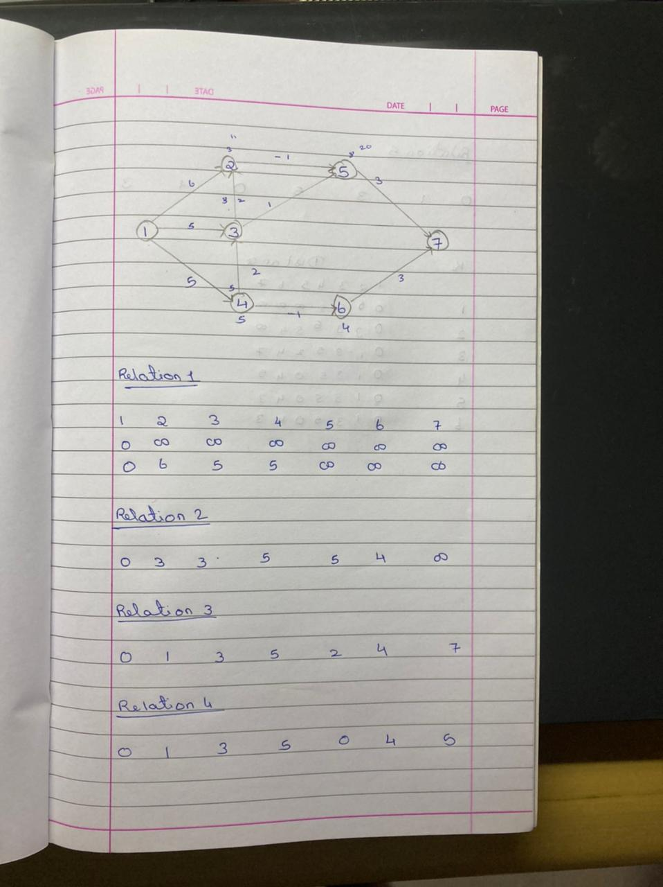

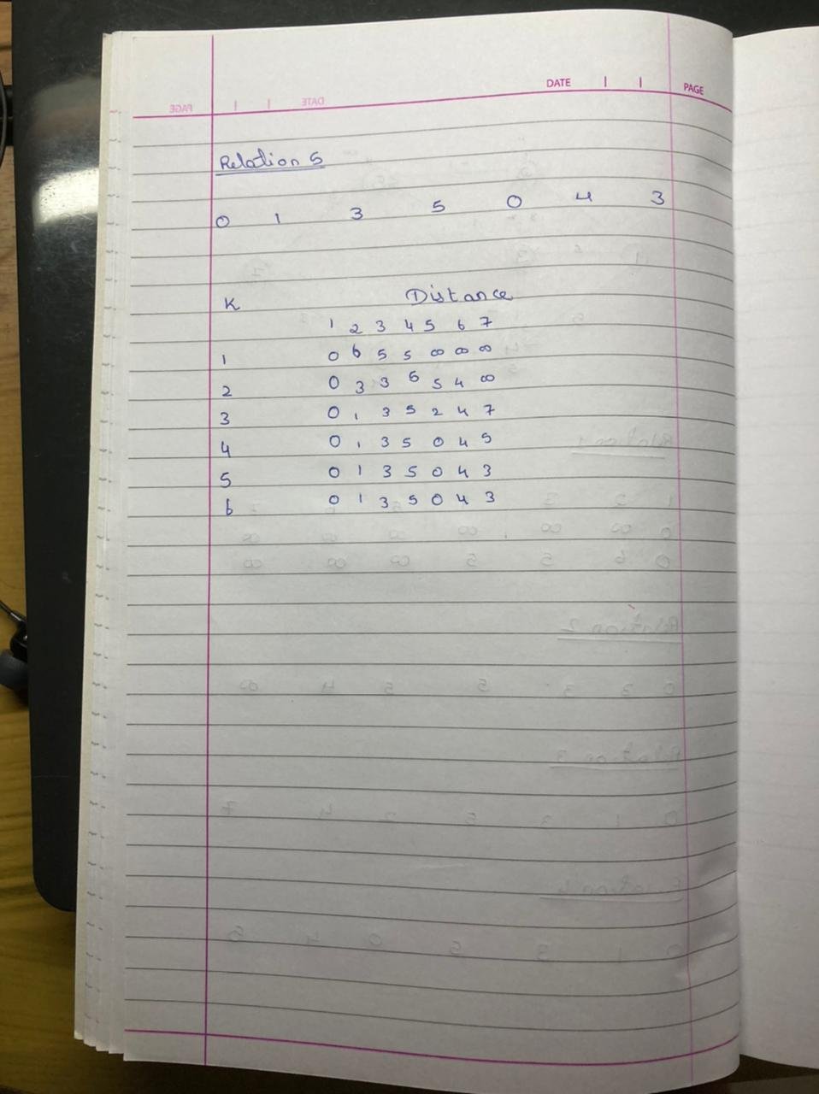

**Program**

#include<bits/stdc++.h>

using namespace std;

int c=0;

typedef struct edge{

int x,y,w;

};

void path(vector<int> parent,int i)

{

c++;

if(parent[i]==-1)

{

c++;

return;

}

path(parent,parent[i]);

c++;

cout<<" - "<<i<<" ";

}

void printPath(vector<int> parent,int src,int n)

{

for(int i=0;i<=n;i++)

{

c++;

c++;

cout<<"Path to "<<i<<" from "<<src<<" : ";

cout<<src<<" ";

path(parent,i);

c++;

cout<<endl;

}

c++;

}

void bellmonFord(vector<edge> v,int n,int e,int S)

{

vector<int> dist(n+1);

for(int i=1;i<=n;i++)

dist[i] = INT_MAX,c++;

c++;

dist[S] = 0;

vector<int> parent(n+1,-1);

for(int i=1;i<n;i++)

{

c++;

for(int j=0;j<e;j++)

{

c++;

c++;

int src = v[j].x;

c++;

int dest = v[j].y;

c++;

int W = v[j].w;

c++;

if(dist[src]!=INT_MAX&&dist[dest]>dist[src]+W)

{

c++;

dist[dest] = dist[src]+W;

c++;

parent[dest] = src;

}

c++;

}

c++;

}

for(int j=0;j<e;j++)

{

c++;

c++;

int src = v[j].x;

c++;

int dest = v[j].y;

c++;

int W = v[j].w;

c++;

if(dist[dest]>dist[src]+W)

{

c++;

cout<<"Negetive Edge Cycle"<<endl;

c++;

return;

}

}

c++;

for(int i=1;i<=n;i++)

{

c++;

c++;

cout<<"The Distance From "<<S<<" To "<<i<<" = "<<dist[i]<<endl;

}

c++;

printPath(parent,S,n);

}

int main()

{

int n,e;

cout<<"**************************"<<endl;

cout<<"Enter The No of Vertices: ";

cout<<"\n**************************"<<endl;

cin>>n;

cout<<"**************************"<<endl;

cout<<"Enter The No of Edges: ";

cout<<"\n**************************"<<endl;

cin>>e;

vector<edge> v(e);

for(int i=0;i<e;i++)

{

int x,y,w;

cin>>x>>y>>w;

v[i].x=x;

v[i].y=y;

v[i].w=w;

}

int S;

cout<<"**************************"<<endl;

cout<<"Enter Souce Vertex: "<<endl;

cout<<"\n**************************"<<endl;

cin>>S;

bellmonFord(v,n,e,S);

cout<<"Step Count: "<<c;

}

**Output**

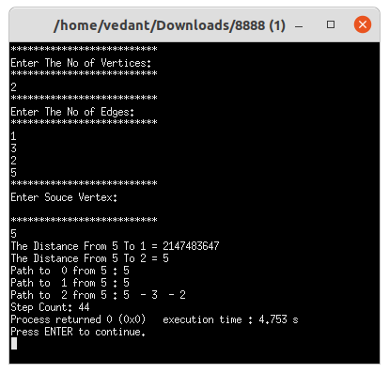

**Conclusion**

* Detailed concept of BellmanFord Algorithm (Dynamic Programming) was studied successfully.
* Program using BellmanFord Algorithm was executed successfully.
* The step count for the BellmanFord Algorithm was obtained.